|  |
| --- |
| Лабораторная работа №6 |
| Решение систем линейных уравнений. |
| Артамоновой Анастасии ПИН-24 |

|  |
| --- |
|  |

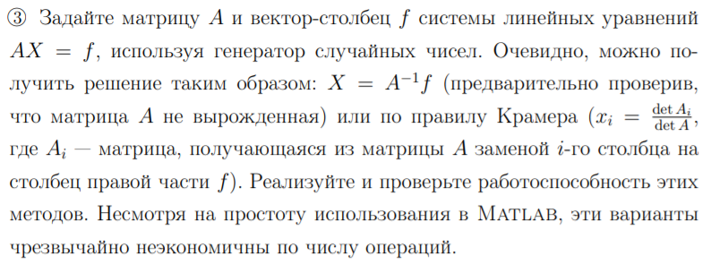

n = 5;

A=fix(rand(n,n)*10)

f=fix(rand(n,1)*10)

if det(A) ~= 0

X = inv(A)*f;

else

disp('Матрица вырожденная, поэтому нельзя использовать метод X = A^(-1)f')

end

X

A =

0 1 1 6 4

0 5 7 2 0

5 4 3 6 2

7 0 5 6 9

9 3 1 7 1

f =

8

5

9

0

4

X =

-0.6818

4.4091

-2.3182

-0.4091

2.0909

**Метод Крамера**

n = 5;

A=fix(rand(n,n)*10)

f=fix(rand(n,1)*10)

for i=1:n

A1=A;

A1(:,i)=f;

X(i,1)=det(A1)/det(A);

end

X

A =

0 7 9 6 0

2 4 5 6 8

8 5 5 3 9

0 2 2 3 7

9 4 4 9 0

f =

2

3

6

1

7

X =

0.5693

0.0068

0.1136

0.1549

0.0420

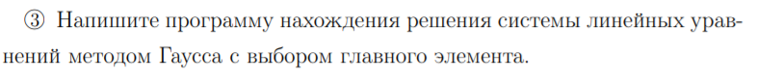

n = 5;

A=fix(rand(n,n)*10)

f=fix(rand(n,1)*10)

for j = 1:n

a =0;

for i = j:n

if a<A(i,j)

a = A(i,j);

m = i;

end

end

S1 = A(j,:);

A(j,:) = A(m,:);

A(m,:) = S1;

f1 = f(j,:);

f(j,:) = f(m,:);

f(m,:) = f1;

for i=j+1:n

if A(i,j) ==0

M(j) = 0;

else

M(j) = A(i,j)/A(j,j);

end

A(i,:) = A(i,:) - M(j)*A(j,:);

f(i,:) = f(i,:) - M(j)*f(j,:);

end

end

A

f

A =

4 5 3 4 7

6 5 9 2 6

7 0 3 1 0

5 7 8 3 8

5 9 4 7 9

f =

7

0

3

7

7

A =

7.0000 0 3.0000 1.0000 0

0 9.0000 1.8571 6.2857 9.0000

0 0 5.3968 -2.3492 1.0000

0 0 0 0.0471 1.9529

0 0 0 0 28.5000

f =

3.0000

4.8571

-5.2698

2.8353

46.5000

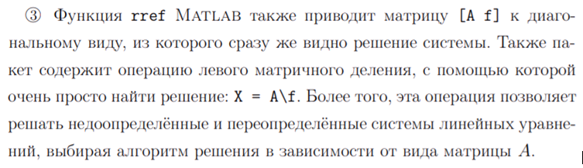

n = 5;

A=fix(rand(n,n)*10)

f=fix(rand(n,1)*10)

rref([A f])

X= A\f

A =

4 7 2 6 7

6 9 2 0 8

9 0 7 3 2

3 3 6 4 7

8 6 5 2 1

f =

8

1

5

3

8

ans =

1.0000 0 0 0 0

0 1.0000 0 0 0

0 0 1.0000 0 0

0 0 0 1.0000 0

0 0 0 0 1.0000

0.1991

0.6604

0.1203

1.3203

-0.7974

X =

0.8474

-1.9141

-0.8183

0.5402

4.5203

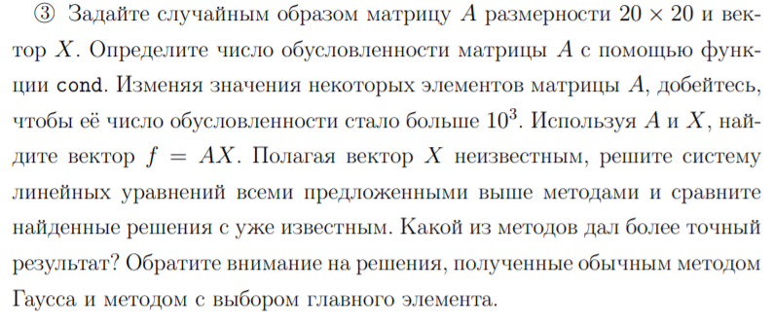

n = 20

k = 5;

A=rand(n,n)+k

X=rand(n,1)

f=A*X

if det(A) ~= 0

X1 = inv(A)*f;

else

disp('Матрица вырожденная, поэтому нельзя использовать метод X = A^(-1)f')

end

X1

for i=1:n

A1=A;

A1(:,i)=f;

X2(i,1)=det(A1)/det(A);

end

X2

X3 = rref ([A f]);

X3 = X3(:,n+1)

X4=A\f

cond(A)

|  |  |  |  |  |  |
| --- | --- | --- | --- | --- | --- |
| Изначальное значение | X = A^(-1)*f; | Правило Крамера | rref | X=A\f | Метод Гаусса |
| X =  0.9469  0.8077  0.1245  0.9662  0.6030  0.6766  0.2427  0.9348  0.5331  0.0088  0.9705  0.8802  0.6473  0.0892  0.6419  0.0732  0.2997  0.6253  0.0288  0.1586 | X1 =  0.9469  0.8077  0.1245  0.9662  0.6030  0.6766  0.2427  0.9348  0.5331  0.0088  0.9705  0.8802  0.6473  0.0892  0.6419  0.0732  0.2997  0.6253  0.0288  0.1586 | X2 =  0.9469  0.8077  0.1245  0.9662  0.6030  0.6766  0.2427  0.9348  0.5331  0.0088  0.9705  0.8802  0.6473  0.0892  0.6419  0.0732  0.2997  0.6253  0.0288  0.1586 | X3 =  0.9469  0.8077  0.1245  0.9662  0.6030  0.6766  0.2427  0.9348  0.5331  0.0088  0.9705  0.8802  0.6473  0.0892  0.6419  0.0732  0.2997  0.6253  0.0288  0.1586 | X4 =  0.9469  0.8077  0.1245  0.9662  0.6030  0.6766  0.2427  0.9348  0.5331  0.0088  0.9705  0.8802  0.6473  0.0892  0.6419  0.0732  0.2997  0.6253  0.0288  0.1586 | X5 =  0.9469  0.8077  0.1245  0.9662  0.6030  0.6766  0.2427  0.9348  0.5331  0.0088  0.9705  0.8802  0.6473  0.0892  0.6419  0.0732  0.2997  0.6253  0.0288  0.1586 |

Число обусловленности

3.6373e+003

A =

10^(-3) 1

1. 2

A =

10^(-3) 1

0 2-10^(3)